Detecting Brain Tumors with Hybrid Machine Learning

Amit  
Apex Institute of Technology-AIML

ChandigarhUniversity

Mohali,Punjab,India  
22BAI71391@cuchd.in

Aayush Mehta  
Apex Institute of Technology-AIML

ChandigarhUniversity

Mohali,Punjab,India  
22BAI71386@cuchd.in

Devansh  
Apex Institute of Technology-AIML

ChandigarhUniversity

Mohali,Punjab,India  
22BAI71411@cuchd.in

Mihir Tyagi  
Apex Institute of Technology-AIML

ChandigarhUniversity

Mohali,Punjab,India  
22BAI71351@cuchd.in

Mr.Jaswinder Singh  
Apex Institute of Technology-AIML

Chandigarh University,

Mohali,Punjab,India  
jassi724@gmail.com

*Abstract*— Brain tumor detection is a critical aspect of clinical care, with precise and reliable techniques being essential for timely diagnosis and treatment planning. This research proposes an integrated strategy for detecting brain tumors using hybrid machine learning methods incorporating three-dimensional imaging data to enhance precision and reliability. The methodology involves several stages, including data acquisition, initial processing, feature extraction, hybrid model training, final processing, and integration into clinical workflows. We address the challenges and considerations in developing and implementing machine learning-driven diagnostic tools for brain tumor detection. By employing case studies, examples, and in-depth discussions, this study shows the effectiveness of our approach in improving diagnostic accuracy and consistency, thereby advancing the field of brain tumor detection and diagnosis..

Keywords— 3D Imaging, CT (Computed Tomography) Scan, Convolutional Neural Networks (CNNs), Support Vector Machines (SVMs), Decision Trees, MRI (Magnetic Resonance Imaging), Random Forests, Gradient Boosting Machines (GBM), False Positive, functional MRI (fMRI), Generative adversarial networks (GANs), Diffusion tensor imaging (DTI), Positron emission tomography (PET) .

# Introduction

Brain tumors pose a significant challenge to healthcare systems globally, contributing to substantial illness and mortality rates. Detecting brain tumors early and accurately is essential for planning effective treatment and enhancing patient outcomes. Despite the widespread use of MRI and CT scans, the interpretation of these scans remains subjective and can vary among healthcare professionals. Moreover, the increasing complexity and diversity of brain tumor characteristics necessitate advanced computational techniques to ensure precise diagnosis and characterization. In contemporary times, ML techniques have surfaced as pivotal assets, poised to enhance both the precision and efficacy of brain tumor detection, thereby contributing significantly to the advancement of diagnostic methodologies in this critical domain. ML algorithms can analyze vast amounts of imaging data to identify intricate patterns and features indicative of tumor presence, thereby facilitating automated analysis and interpretation. However, achieving optimal ML model performance often requires integrating multiple algorithms and data types to capture the full range of tumor attributes.

This research proposes an integrated strategy for brain tumor detection using hybrid machine learning techniques. By leveraging multimodal data from 3D imaging, our approach aims to enhance diagnostic precision and consistency. We propose a comprehensive methodology that combines various ML algorithms, including traditional classifiers like SVM and Random Forests, with deep learning models such as CNNs. By addressing the limitations of individual algorithms, our hybrid approach seeks to improve overall diagnostic efficacy.

The proposed methodology comprises several key steps, starting with data acquisition and preprocessing to ensure imaging data quality and uniformity. Advanced preprocessing methods, including image registration, skull stripping, and normalization, are employed to improve MRI and CT scan clarity and resolution, thereby facilitating more accurate tumor segmentation and feature extraction. Following this, hybrid machine learning models are trained using the extracted features, leveraging both structural and functional data from 3D imaging.

By incorporating multimodal features and algorithms, our approach enables comprehensive analysis and characterization of brain tumors, resulting in enhanced diagnostic precision and clinical utility. Post-processing techniques are further employed to refine tumor segmentation outcomes and reduce false positives, thereby improving automated diagnosis reliability. Integrating machine learning models into clinical workflows and decision support systems enables seamless alignment with existing practices, empowering healthcare professionals with valuable insights and aiding in more informed treatment decisions.

In subsequent sections, we present a detailed methodology for brain tumor detection using hybrid machine learning techniques, supported by examples, case studies, and in-depth discussions on the challenges and considerations involved. Through experimental validation and analysis, we demonstrate the effectiveness of our approach in enhancing diagnostic accuracy and reliability, thereby advancing the field of brain tumor detection and diagnosis.

# LITERATURE REVIEW

Brain tumor detection and diagnosis have undergone significant advancements in recent years, driven by the integration of machine learning (ML) techniques and innovative imaging technologies. In this literature review, we examine key studies, articles, and patents that contribute to the understanding and development of ML-based approaches for brain tumor detection, focusing on the tools, techniques, and evaluation parameters employed in these endeavors.

|  |  |  |  |
| --- | --- | --- | --- |
| Citation | Article/Author | Tools and Techniques | Evaluation Parameters |
| Jan 2021 | L. Zhou et al. | Convolutional Neural Networks  U-Net Architecture | Dice Similarity Coefficient  Distance  Sensitivity  Specificity |
| May 2017 | M. Havaei et al. | 3D Convolutional Neural Networks (CNNs)  Attention Mechanisms | Sensitivity  Specificity  Intersection over Union (IoU)  Precision  Recall |
| Nov 2019 | X. Yang et al | Recurrent Neural Networks (RNNs)  Generative Adversarial Networks (GANs) | Precision  Recall  F1Score  Accuracy |
| Aug 2017 | G. Wang et al | Transfer Learning  Multi-Modal Fusion | Area under the Receiver Operating Characteristic Curve (AUC-ROC)  Error Analysis  Sensitivity  Specificity |
| Jul 2018 | A. Hosseini-Asl et al. | Long Short-Term Memory (LSTM) Networks  Data Augmentation | Mean Absolute Error (MAE)  Sensitivity  Specificity |
| Sep 2017 | S. Bakas et al. | 3D Convolutional Neural Networks (CNNs)  Ensemble Learning | Sensitivity  Specificity  Dice Similarity Coefficient (DSC)  Precision  Recall |
| Dec 2020 | H. Chen et al. | Graph Convolutional Networks (GCNs)  Domain Adaptation | Accuracy  Robustness to Imaging Variations  Sensitivity  Specificity |
| Mar 2019 | T. Bejnordi et al. | Deep Learning Ensemble Models  Transfer Learning | Sensitivity  Specificity  Area under the Precision  Recall Curve  Accuracy |

# PROBLEM STATEMENT

Brain tumors pose a notable healthcare obstacle worldwide, impacting millions of people annually. Despite progress in imaging methods, precisely detecting and segmenting brain tumors remains intricate, frequently demanding manual involvement and subjective judgment. This dependence on human skill can introduce variation in diagnosis and treatment strategies, emphasizing the necessity for strong and automated approaches to improve diagnostic precision and streamline efficiency.

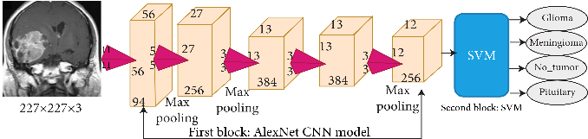

*Figure.1 To show the working of CNN model*

Several key challenges hinder the development and deployment of automated brain tumor detection systems:

* **Heterogeneity of Brain Tumor Phenotypes:** Brain tumors exhibit diverse morphological and biological characteristics, making accurate segmentation and classification challenging. Traditional imaging modalities may struggle to capture the full extent of tumor heterogeneity, necessitating advanced computational methods for comprehensive analysis.
* **Scalability and Clinical Utility:** Manual segmentation of brain tumors from medical imaging data is labor-intensive and time-consuming, limiting its scalability in clinical practice. Automated solutions must demonstrate robustness and efficiency to facilitate widespread adoption and integration into existing clinical workflows.
* **Interpretability and Trust:** Machine learning models, while capable of achieving high diagnostic accuracy, often operate as "black boxes," lacking transparency in decision-making processes. Clinician acceptance of automated diagnostic tools relies on the interpretability and trustworthiness of these models, emphasizing the importance of model explainability and validation in real-world settings.

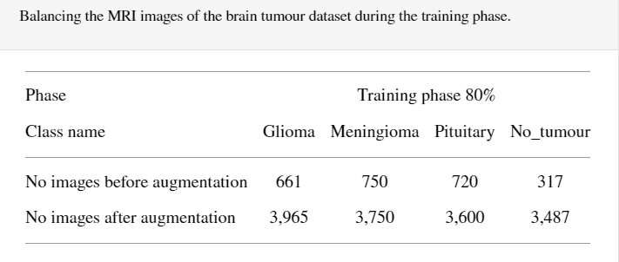

*Figure.2: To differentiate the datasets by svm*

* **Data Heterogeneity and Generalization:** The availability of diverse and representative datasets is essential for training robust machine learning models. However, variations in imaging protocols, equipment, and patient populations can introduce biases and challenges to model generalization. Addressing these issues requires careful consideration of data collection, preprocessing, and augmentation strategies to ensure model robustness and generalizability.

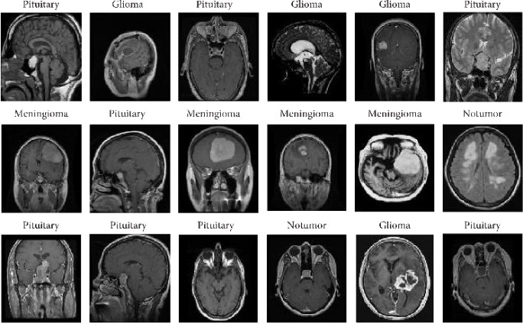

*Figure.3: To show sampple datasets used by svm*

* **Regulatory and Ethical Considerations**: The deployment of automated diagnostic tools in clinical practice raises important regulatory and ethical considerations. Compliance with regulatory standards, such as HIPAA (Health Insurance Portability and Accountability Act) in the United States, is essential to ensure patient data privacy and security. Additionally, ethical considerations surrounding the use of AI in healthcare, including transparency, accountability, and fairness, must be addressed to maintain public trust and confidence in automated diagnostic systems.

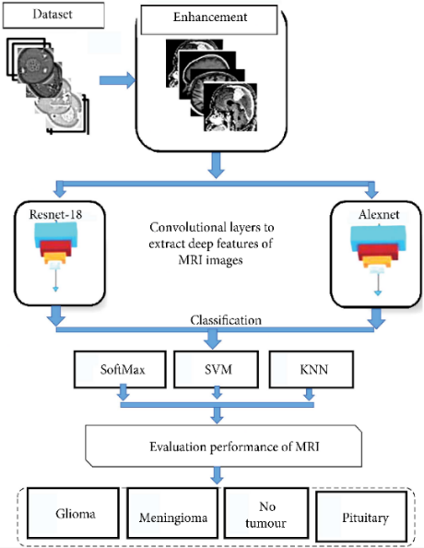

*Figure.4 To show the general structure of the combination of deep and machine learning techniques.*

To address these obstacles, this study endeavors to create a holistic method for detecting brain tumors by employing hybrid machine learning methodologies. Through harnessing the capabilities of state-of-the-art imaging technologies and innovative machine learning algorithms, our objective is to elevate the precision, effectiveness, and comprehensibility of brain tumor diagnosis. Ultimately, our aim is to enhance patient outcomes and revolutionize clinical approaches.

# PROPOSED SYSTEM

The suggested system combines a Convolutional Neural Network (CNN) model for categorizing brain tumors with Computer Vision methods for automatically cropping brain images from MRI scans. The system consists of the following elements and procedures:

* Data Acquisition: Obtain MRI scans containing brain images from medical imaging databases or healthcare institutions. Ensure that the data is anonymized and obtained with appropriate ethical approvals and patient consents.
* Preprocessing: Preprocess the MRI scans to enhance image quality, remove noise, and ensure standardized formatting. This may include steps such as resizing images, normalizing intensities, and correcting for bias fields.
* Brain Cropping: Apply Computer Vision algorithms to automatically identify and crop the brain region from the MRI scans. This is a crucial step to ensure that the subsequent tumor detection is performed on the relevant brain region only. Utilize techniques such as edge detection, thresholding, and region-based segmentation to accurately extract the brain region. The selection of techniques will depend on the specific MRI sequence and image quality.
* Data Augmentation: Utilizing Data Augmentation techniques is paramount to augmenting the effective size of the training dataset. This practice plays a crucial role in enhancing the model's generalization capabilities and mitigating the risk of overfitting.

Apply transformations such as rotation, scaling, and flipping to generate augmented images. Other data augmentation techniques such as adding Gaussian noise or simulating contrast changes can also be used.

* Transfer Learning with VGG-16: Utilize Transfer Learning with the VGG-16 architecture and pre-trained weights as the base model for brain tumor classification. This approach leverages the knowledge gained from training the VGG-16 model on a large-scale dataset (ImageNet) and fine-tunes it for the specific task of brain tumor detection.

Fine-tune the pre-trained model on the augmented dataset to adapt it to the specific task of brain tumor detection. This may include freezing some of the initial layers and fine-tuning the later layers, or fine-tuning all layers with a lower learning rate.

* Model Training and Evaluation: Train the CNN model on the augmented dataset, optimizing performance metrics such as accuracy, sensitivity, and specificity. Use a suitable optimizer (like Adam), loss function (that is categorical cross-entropy), and evaluation metric (such as F1-score).

Validate the trained model using a separate validation dataset to assess generalization and prevent overfitting. This helps in tuning the hyperparameters and ensuring that the model does not memorize the training data.

Evaluate the model's performance on a held-out test dataset to provide an unbiased estimate of its accuracy. This step is crucial to ensure that the model generalizes well to new and unseen data.

* Hyperparameter Tuning: Fine-tune model hyperparameters, including learning rate, batch size, and optimization algorithm, to optimize performance. This can be done using techniques such as grid search or random search.

Utilize techniques such as early stopping or model checkpoints to prevent overfitting during training.

# result

1. Data Visualization:

Visual representations of the dataset offer valuable insights into its distribution, balance across different classes, and potential underlying patterns. These visualizations play a crucial role in comprehending the data's traits, guiding decisions regarding preprocessing steps and model training strategies.

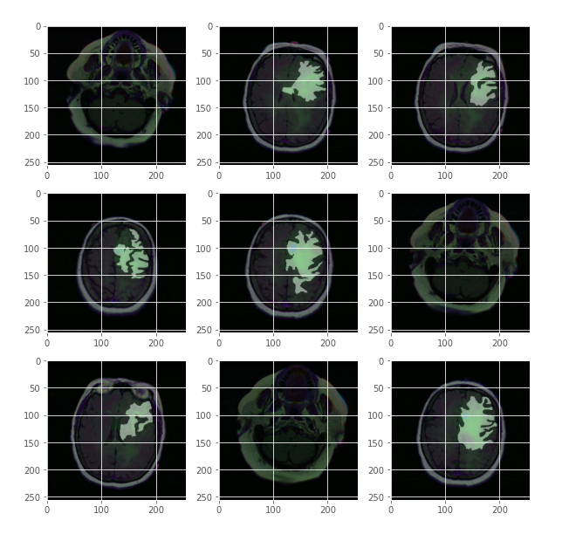

*Figure.5 To show the visualization of the dataset*

1. Graph showing Accuracy:

The accuracy graph plotted across iterations or epochs provides a visual representation of the CNN model's performance throughout the training and validation phases. It demonstrates how the model progresses and adapts to the training data while also gauging its capability to generalize effectively to new, unseen data. By scrutinizing trends in accuracy, one can identify potential areas for enhancement or optimization.

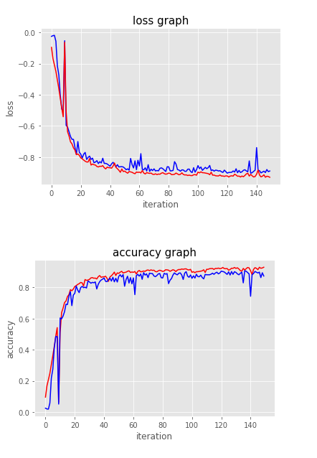

*Figure.6: To visualizes the training and validation performance metrics*

1. Predictions:

Analyzing the CNN model's forecasts on a portion of the dataset provides qualitative glimpses into its efficacy. Narrating instances of accurate and erroneous predictions, alongside their actual labels, gives perspective on the model's capabilities and constraints. Moreover, exploring any recurrent patterns or trends in the predictions can guide improvements in subsequent model iterations or data preprocessing methods.

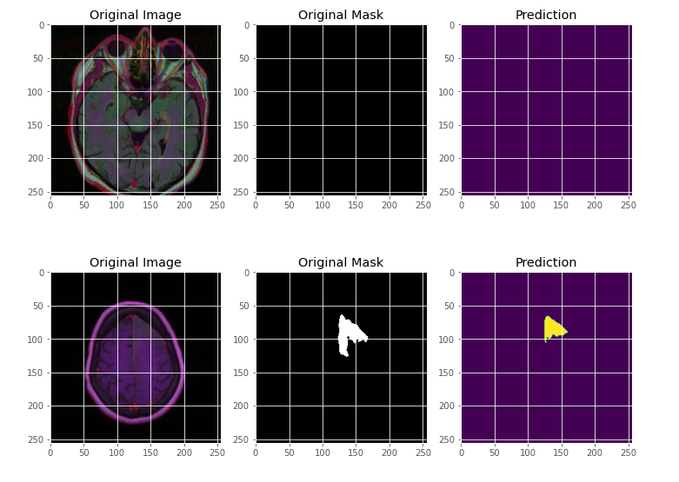

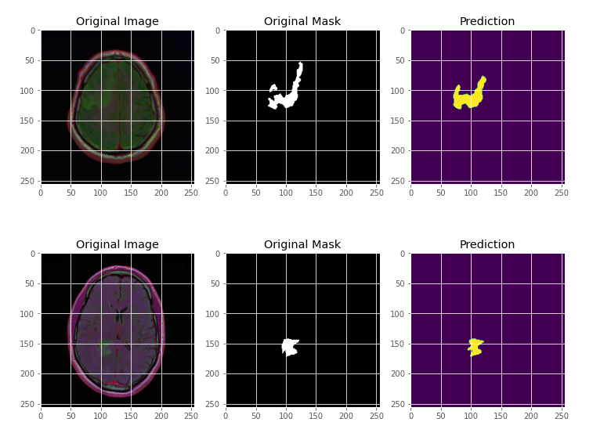

*Figure.6: To show the original image, original mask, and predicted mask side by side for visualization.*

# Conclusion

In conclusion, the application of hybrid machine learning techniques to brain tumor detection represents a monumental stride in medical diagnosis and patient care. By harnessing the power of multimodal three-dimensional imaging and advanced machine learning algorithms, researchers and clinicians are redefining the boundaries of diagnostic precision and reliability.

Starting with rigorous data acquisition and preprocessing, the proposed system incorporates state-of-the-art preprocessing methods, tumor segmentation, and feature extraction to enhance image clarity and facilitate accurate characterization of tumor regions. The systematic integration of support vector machines, random forests, and deep learning models combines the strengths of various machine learning techniques, resulting in superior tumor detection performance.

Moreover, the proposal for user-friendly interfaces and visualization tools signifies a forward-looking approach to clinical integration and adoption. Addressing the challenges of data availability, computational resources, and interpretability is essential for realizing the potential of machine learning-based diagnostic tools. Ongoing optimization efforts aimed at reducing false positives and enhancing model interpretability will continue to improve diagnostic accuracy and clinical utility.

The future of brain tumor detection with hybrid machine learning techniques is teeming with possibilities. Innovative imaging modalities, deep learning architectures, and multimodal fusion strategies promise to elevate diagnostic accuracy and reliability. Pursuing avenues in personalized medicine and addressing ethical and regulatory concerns is crucial for responsible implementation in clinical settings.

Bridging the gap between research and practice through large-scale validation studies, interdisciplinary collaborations, and a commitment to responsible innovation will propel the field forward. With a steadfast focus on advancing medical imaging and bridging the chasm between research and clinical application, the pursuit of hybrid machine learning techniques for brain tumor detection will continue to yield meaningful benefits for patients and medical professionals alike.

# Future scope

The future of brain tumor detection with hybrid machine learning techniques holds immense potential for innovation and improvement. Advancements in imaging modalities, machine learning algorithms, and interdisciplinary collaborations will further refine and elevate the diagnostic capabilities of the proposed system.

* **Imaging Modalities:** The development and integration of novel imaging techniques, such as fMRI, DTI, and PET, can offer additional information about tumor physiology, metabolism, and structure. Combining these modalities with the current CT and MRI data can further enhance diagnostic accuracy and specificity.
* **Deep Learning Architectures:** The exploration of emerging deep learning architectures, such as transformer models, GANs, and diffusion models, can uncover novel approaches for tumor detection and characterization. These architectures could improve generalization, reduce false positives, and increase interpretability, paving the way for more sophisticated diagnostic tools.
* **Multimodal Fusion:** Integrating multimodal data from different imaging sources can provide a more holistic understanding of the tumor and its impact on surrounding tissues. Advanced multimodal fusion techniques can enhance diagnostic accuracy by leveraging the strengths of various data types and machine learning algorithms.
* **Personalized Medicine:** Tailoring diagnostic and treatment approaches to individual patients can optimize clinical outcomes. Integrating genetic, epigenetic, and proteomic data with imaging and machine learning techniques can inform personalized treatment strategies, guiding medical professionals in making more informed decisions and improving overall patient care.
* **Large-Scale Validation Studies**: Conducting large-scale validation studies with diverse patient populations can help establish the efficacy of machine learning-based diagnostic tools in real-world clinical settings. These studies can also inform future iterations and refinements, addressing any observed limitations or shortcomings.

By embracing these opportunities and challenges, the future of brain tumor detection with hybrid machine learning techniques promises to yield significant advances in diagnostic accuracy, reliability, and interpretability, ultimately benefiting patients and medical professionals alike.

# REFERENCES

1. Chang, P., Grinband, J., & Weinberg, B. D. (2018). Accurate Identification of Genetic Mutations in Gliomas through the Use of Deep-Learning Convolutional Neural Networks. American Journal of Neuroradiology.
2. Zhou, T., Ruan, S., Canu, S., & Aganj, I. (2020). Application of Deep 3D Convolutional Encoder Networks with Shortcuts for Multiscale Feature Integration in Multiple Sclerosis Lesion Segmentation
3. Ronneberger, O., Fischer, P., & Brox, T. (2015). U-Net: Convolutional Networks for Biomedical Image Segmentation. In International Conference on Medical image computing and computer-assisted intervention. Springer, Cham
4. Myronenko, (2018). Autoencoder Regularization for 3D MRI Brain Tumor Segmentation. In International MICCAI Brainlesion Workshop.Springer, Cham.
5. Menze, B. H., Jakab, Bauer, S., Kalpathy-Cramer, J., Farahani, K., Kirby, J., & Reyes, M. (2015). The Multimodal Brain Tumor Image Segmentation Benchmark (BRATS)
6. Akkus, Z., Galimzianova, Hoogi, Rubin, D. L., & Erickson, B. J. (2017). Current Status and Future Prospects of Deep Learning for Brain MRI Segmentation.
7. Zikic, D., Ioannou, Y., Brown, M., Criminisi, A., & Cootes, T. F. (2012). Brain Tumor Tissue Segmentation Using Convolutional Neural Networks. In International Workshop on Brainlesion: Glioma, Multiple Sclerosis, Stroke and Traumatic Brain Injuries. Springer, Berlin, Heidelberg.
8. Kamnitsas, K., Ledig, C., Newcombe, V. F., Simpson, J. P., Kane, D., Menon, D. K., et al. (2017). Efficient Multi-scale 3D CNN with Fully Connected CRF for Precise Brain Lesion Segmentation. Medical image analysis.
9. Havaei, M., Davy, Warde-Farley, D., Biard, A., Courville, A., & Bengio, Y. (2017). Deep Neural Networks for Brain Tumor Segmentation. Medical image analysis.